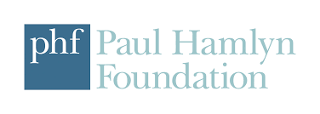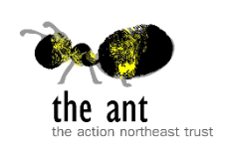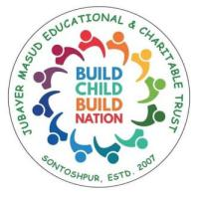

**Livelihood Support program**

**For underprivileged families**

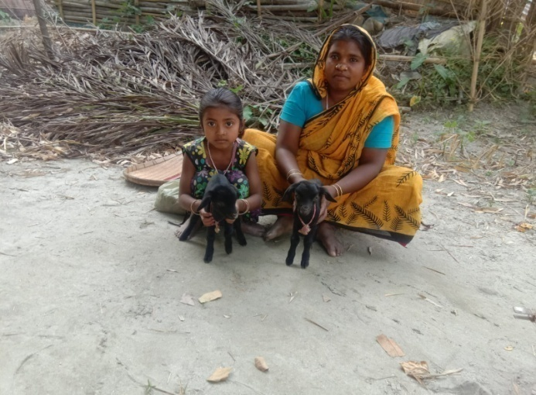

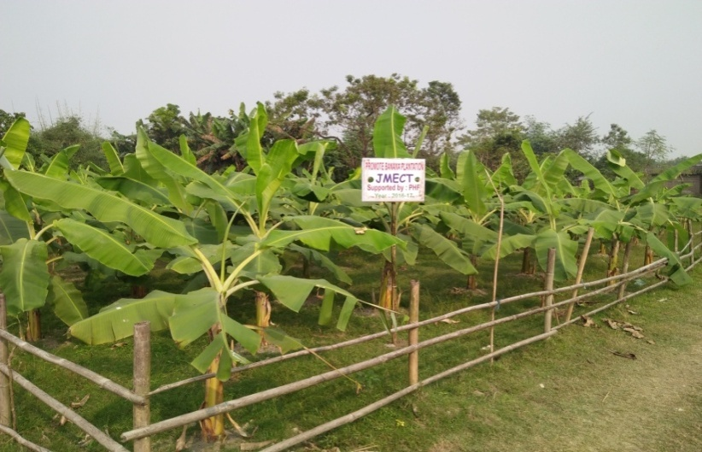

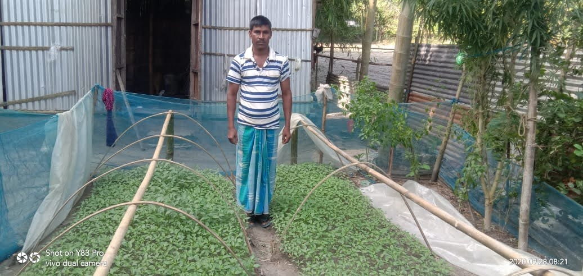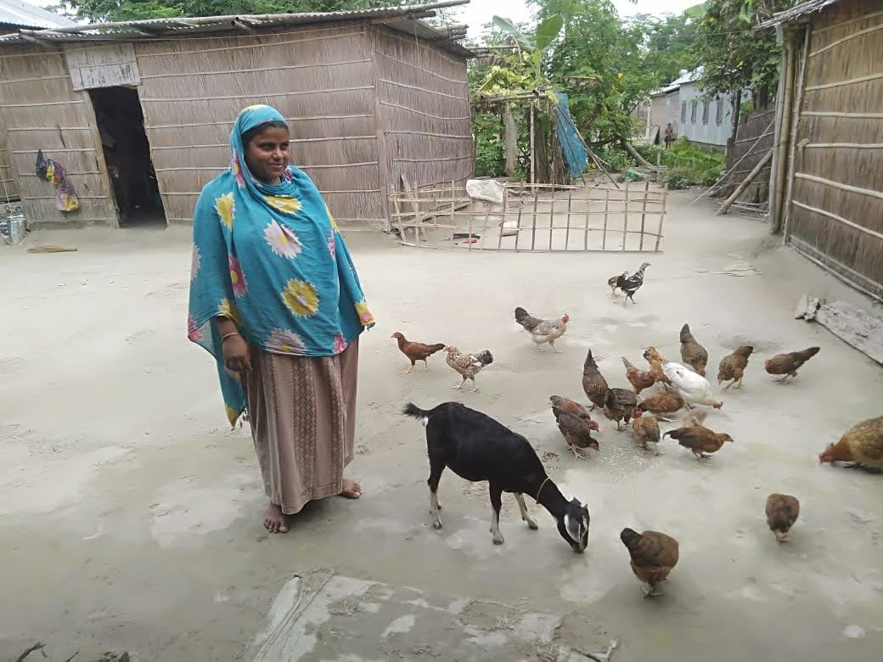

**JUBAYER MASUD EDUCATIONAL & CHARITABLE TRUST**

**Vill. Sontoshpur Pt. II, Sontoshpur. Dist. Bongaigaon. Assam**

WebPage: www,jmect.in

**Summery**

In response to the pressing challenges faced by the rural community residing in riverine regions, JMECT has implemented a strategic program targeting these vulnerable areas. These regions are particularly susceptible to annual flooding, resulting in the loss of land and property, and destabilizing the livelihoods of the inhabitants. The ripple effect of these challenges is felt keenly, as families often struggle to meet basic needs, prioritizing home rebuilding over education due to the cyclical nature of the floods. Consequently, children experience irregular attendance and an increase in dropout rates.

Acknowledging the complexity of the issue, JMECT has proactively taken steps to address the multifaceted challenges faced by communities in riverine areas. The organization aims to break the cycle of poverty and lack of education by providing targeted educational support to the children in these regions. Concurrently, JMECT is dedicated to alleviating economic burdens by implementing free livelihood support initiatives, particularly through goat rearing, banana cultivation, interest-free revolving loans, and cash-for-work programs. This approach ensures sustainable income generation for families, creating a pathway towards financial stability and resilience.

|  |  |  |
| --- | --- | --- |
| Type of Livelihood | Period | Number of families |
| Goat Farming | 2017-2024 | **426** |
| Interest Free Revolving Loan | 2020-2022 | **377** |
| Cash for work | 2021-2022 | **256** |
| Entrepreneurship | 2021-2020 | **7** |
| Banana Farming | 2016-2018 | **198** |
|  |  | **1264** |

From 2017 to 2024, JMECT has significantly impacted vulnerable regions by providing 426 goats to

beneficiaries. Additionally, the organization has offered interest-free revolving loans to 377 families, implemented cash-for-work programs benefiting 256 families with 3315 mandays during the 2020-2022 period, supported banana plantation initiatives for 198 families, and provided entrepreneurship opportunities to 7 families. This comprehensive strategy not only addresses the immediate educational needs of children but also ensures the long-term economic well-being of families, thereby contributing to the overall upliftment of these communities. The success and sustainability of JMECT's initiatives highlight the organization's dedication to making a positive difference in the lives of those facing adversity in riverine regions.

JMECT's beneficiary selection process involves identifying the most economically disadvantaged students enrolled in supported centers. Prior to extending support, the organization ensures transparency by clearly outlining terms and policies to the beneficiaries. These terms include the necessity of opening a bank account in the child's name and committing a portion of the income generated from goat rearing towards the child's education. This meticulous approach aims to create a fair and accountable system, fostering transparency and ensuring that the support provided directly contributes to the educational well-being of the identified students

**Goat Farming**

**Goat Support to parents of school going children :** The "Goat Support to Parents of School-Going Children" program is a transformative initiative aimed at providing crucial assistance and empowerment to families with school-going children. The program recognizes the interconnectedness of economic stability, education support, and sustainable livelihoods in fostering the overall well-being of these families.

**2017-2019**

During the fiscal years 2017-2019, JMECT initiated the livelihood support program, marking a significant milestone by supplying 143 goats to beneficiaries. The latest report from 2022 revealed that beneficiaries, supported by JMECT through goat rearing, collectively earned a total of 7,40,400 rupees through the sale of goat kids, with 146 kids remaining.

**2022-2023**

In April 2023, JMECT distributed 184 goats to 184 families, meticulously documenting each beneficiary's details. Unfortunately, 74 goats succumbed to various health issues, leaving 110 goats in good health. Despite this setback, 140 healthy goat kids were born. In an effort to extend support, female goat kids from the initial births are being collected and distributed to another 11 beneficiaries who meet predefined criteria.

**2023-2024**

In February 2024, JMECT continued its commitment to supporting communities by providing livelihood assistance to an additional 65 beneficiaries. This initiative not only aids these families directly but also ensures the sustainability of the program by redistributing offspring to new beneficiaries. The cyclical nature of the program helps create a self-sustaining ecosystem, empowering more individuals and families in the process.

**Key Components of the Program**

Identification of Beneficiaries: Families with school-going children are carefully identified based on economic need, the number of children attending school, and the family's commitment to active participation in the program.

**Livelihood Support through Goats:** Beneficiary families receive goats as a primary means of livelihood support, offering them the potential to generate income through the sale of offspring, milk, or other related products.

**Economic Empowerment:** The goats provided through the program serve as a sustainable source of income for parents, enhancing economic stability and creating opportunities for further development through responsible goat rearing practices.

**Education-Related Expenses**: Income generated from goat rearing is directed towards covering various education-related expenses, including school uniforms, textbooks, and tuition fees, alleviating the financial burden on parents and allowing children to pursue education unhindered.

**Training and Support**: Beneficiaries receive training and ongoing support to ensure the health and well-being of the goats, encompassing proper care, nutrition, and breeding practices. This fosters sustainable livelihoods and promotes responsible animal husbandry.

**Community Development:** The program extends beyond individual households, contributing to the overall development of the community. By uplifting the economic status of parents with school-going children, it creates a positive ripple effect, fostering a sense of empowerment and self-sufficiency within the broader community.

**Goat support to Victim of Domestic violence 2021-2022**

During the fiscal year 2021-2022, our organization implemented a meaningful livelihood support program, where we distributed a total of 23 goats to vulnerable women who have endured the challenges of domestic violence. This initiative aimed not only to provide immediate assistance but also to empower these women to regain control of their lives.

In the year 2021, our efforts were directed towards supporting 10 beneficiaries through our Goatery program. These women received not just goats but also comprehensive assistance and training to ensure the success of their goat rearing endeavors. We believe in a holistic approach that goes beyond mere distribution.

Building on the success of the previous year, our support expanded in 2022 to reach an additional 13 beneficiaries. This expansion signifies our commitment to making a lasting impact on the lives of these women. The goal is not only to offer them a source of income through goat rearing but also to foster sustainable livelihoods that empower them to break free from the cycle of domestic violence.

Through these initiatives, we strive to create a positive ripple effect within the community, demonstrating the transformative power of support, education, and economic empowerment.

Top of Form

**Some pictures of Goat Distribution & Beneficiaries**

