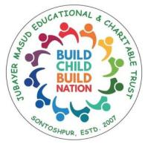

**Education program**

**For underprivileged Children**

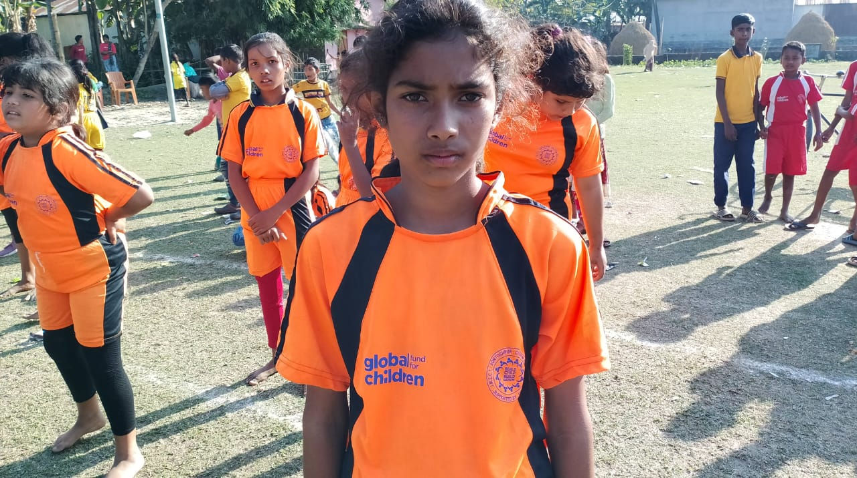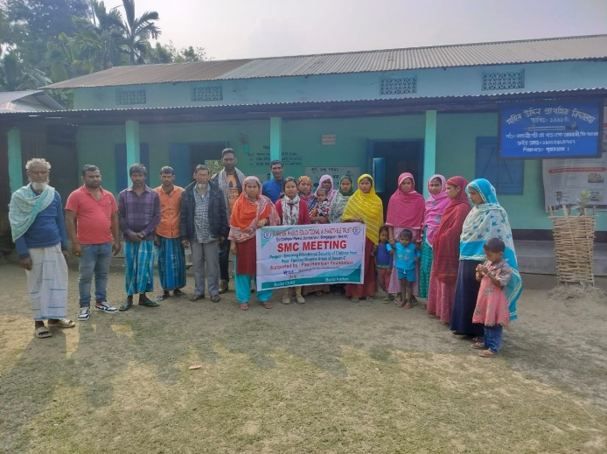

**JUBAYER MASUD EDUCATIONAL & CHARITABLE TRUST**

**Vill. Sontoshpur Pt. II, Sontoshpur. Dist. Bongaigaon. Assam**

Web Page: www,jmect.in

**Summery**

The Bongaigaon district faces profound challenges stemming from extreme poverty, inadequate access to basic amenities, and prevalent social issues such as child labor and early marriage. With 90% of the population belonging to minority communities and 10% to Scheduled Castes, economic struggles are pervasive, compelling families to prioritize survival over education. The predominant livelihood, agriculture, is often disrupted by floods, pushing families into precarious occupations like construction labor and brick-making.

Child marriage compounds these challenges, hindering young people's education and perpetuating cycles of poverty and gender inequality. Despite efforts to promote education, many children are forced to drop out of school to support their families financially. The lack of incentives and opportunities for education, coupled with seasonal migration for employment, exacerbates high dropout rates in the region.

In addition to economic hardships, poor education standards persist due to neglect, inadequate infrastructure, and uninspiring teaching methods. Parental neglect and community indifference further contribute to irregular attendance and dropout rates. Government schools often lack essential facilities and suffer from ineffective management, leading to a substandard learning environment.

Furthermore, contemporary youth face myriad challenges, including globalization, drug abuse, and the allure of digital entertainment, making them susceptible to negative influences. Addressing these complex issues requires targeted interventions aimed at empowering youth to make positive choices and actively participate in shaping their future and that of their community.

In response to these challenges, an organization initiated an education program in 2008, starting small and gradually expanding to cover 28 villages and reach 1264 children annually. The program encompasses early childhood education, remedial classes for academically weak children, dropout prevention initiatives, awareness campaigns, and the formation of children's associations. By providing holistic support and empowerment opportunities, the program aims to break the cycle of poverty and empower youth to become agents of positive change in their communities.

Top of Form

To enhance the education scenario in the Bongaigaon district and address the multifaceted challenges faced by the community, we are implementing the following comprehensive program:

**Education Program**

:MECT has been working in a region of Bongaigaon ,Assam that has one of the lowest literacy rates among districts. Factors contributing the issues including illiteracy,poor economic conditions, frequent flooding and lack of awareness and motivation.Initially JMECT has worked with 13 students in one village at Sontoshpur II using grants received from various organizations since then ,it has expanded it’s efforts to 30 villages,reaching 17000 children.The organization's primary objective is to improve the quality education,teaching method and quality of schooling in existing schools within the existing framework of government curriculum to make changes and to provide better education to each child.

The various education related program are mention below

**Early Child Education**

Early childhood care and education (ECCE) is more than preparation for primary school. It aims at the holistic development of a child’s social, emotional, cognitive and physical needs in order to build a solid and broad foundation for lifelong learning and wellbeing. ECCE has the possibility to nurture caring, capable and responsible future citizens.

Here the concern JMECT is to support govt. schools that have been facing problems in management due shortage of teachers where there is huge gape of teacher student ratio . By providing additional teachers of JMECT could fulfill the gap of teacher student ratio.

Though the focus was to support the govt. schools, JMECT always took tend to follow own models of teaching.

JMECT has been working with Govt. schools. Before the intervention many children were out of reach from the teacher as the number of children was huge. But the teacher support from JMECT could extend and provided better service and thus attention could be spread to all the children. Around 8500 children are reach out in this intervention

**Remedial Teaching**

Due to several causes a number of children are not achieving grade appropriate learning competency.

A number of children lacked basic literacy and numeracy could not participate at the level of their grade. These children is provide support to achieve certain competencies, so that gradually they gather confidence and cope up in the regular classes. With the help of diagnostic baseline assessment learning level of each child is identify and make an individual plan for remediation and bridging at their appropriate grade. with the bridging taught in a manner. During our intervention we found that a section of students were far behind from their grade appropriate level. Around 10500 children is given learning support through this process. Yearly about one thousand children are benefitted under this program .

**Model Education Centre**

Towards the achievement of it’s vision JMECT has been giving tremendous emphasis on education since the inception of the organization. As the development of education is the prime focus of the organization all the activities undertaken were carried out realizing the issues related to the education. JMECT is the only organization in the region to render excellent services for the poor and deprived children living in rural areas of Bongaigaon. It’s concentration areas lies in so remote and char areas. Majority of the people are illiterate and poor. The education status indicates one of the lowest literacy rate in comparison to other district. Due to seasonal flood people face problem in their living and children gets hampered in their learning and schooling. Some of the advantaged people teach their children in private and town areas. Disadvantaged children are left out from accessing quality education. JMECT has emerged to take positive step to uplift these children. Accordingly J.M. Academy was opened to give service to the poor and marginalized children of the region. Within short period of intervention the school has come up with positive result. By introducing various joyful method of teaching and by utilizing valuable TLM the children could be improved. It’s supported on alternative system of education where physical, mental, social and spiritual development in children has been trying with joyful method of teaching and learning. The education centre has been running successfully and smoothly where yearly 1660 children are taking education and 5030 children are cover under this program .

**Education during Pandemic**

Due to the Lockdown in India, the unexpected school shutdown increases the probability of drop out rate of the rural students by their schooling gap. Under such situation, JMECT is implementing a special design education a module to continue in touch with a minimum learning activity which can reduce the probability of drop out rate. The main objective of the special designed curriculum is to keep the students involve in daily activity that can lead them nearer to their studies. Reach out 460 children under this program .

**Transit Learning centre**

JMECT has set up three Transit learning center at at new berajan SBI brick quarry,Kekakuli Miri , Baithabhanga ABF brick quarry of Sonitpur district to reach out the children of our project area who are migrated with their parents . As it is known fact that the seasonal migration is common problems of our project area. Numbers of families are migrated to various brick factory in search of job due to poor economic background. In such situation their children became victim of being deprived by right to education.This is the one of major reason of school dropout of the region. Under such circumstances the organization set up three Transit learning centre on November,2022 which is based our survey where we have found most of the migrant students in these three particular location where we have opened the centres where maximum numbers of the students were found. Total 63 children are covered in these transit learning centre.

**Capacity Building**

For the capacity building of the staff we have conducted different activities cum training the activities are mention below:

**Teacher’s Training Programme**

JMECT conducted teacher training program at JMECT training core focuses is on providing quality training for educational facilitators who teach at the primary level.To achieve this objective, organization brings resource persons who have significant experience in the field of education are well versed in the latest teaching methodologies.

**TLM Workshop:**

One of the key aspects of the training provided at JMECT is the creation of TLM these materials are designed to aid in the delivery of lessons which help students for better understand the concepts being taught.For better outcomes we conducted a TLM workshop programme to develop new TLM to build a capacity for TLM making we provided resource person and under his guidance and support the educational facilitator creating these TLM materials. Additionally JMECT arranges different raw materials required for designing for each staff TLM.It had also discussed the concepts of pre-primary education and FLN(Functional literacy and numeracy)the training focused on the use of teaching and learning materials and the proper transition of the teaching and learning process.

**Exposure visit of Staff:**

JMECT Staff embarked on a exposure visit to Rajasthan from January 21st January 2023 to 29th January 2023.During their visit ,they visited two different organizations, namely Gramin Siksha Kendra located in Sewai Madhurpur and barefoot college in Tiloniya. The purpose of the visit was to gather information and gain experience from these organization regarding their approach towards their community development, with a focus on the importance of education,women’s empowerment, and community involvement.Through their visit,JMECT gained valuable insights into the innovation methods adopted by these organization to address the challenges faced by the community.They were particularly impressed by the dedication and commitment of these organization towards promoting education and empowering women.Overall the exposure visit proved a fruitful leaning experience for JMECT providing them with a deeper understanding of the importance of community participation in bringing about sustainable changes.

**Monthly Staff review Meeting**:

The monthly staff review meeting is conducted once in every month and which is a important platform for all the project members, staffs of the project including from GFC,PHF and AVAHAN project etc. The meeting servers as an opportunity to discuss monthly activities,exchange ideas, provide suggestion and address problems. It also focuses on the development of the theme-based lesson plans and the implementation of the training- based learning, which reviewed in the meeting.The availability of TLM in the centers as well as the shortage of the required materials,is also an usual point of discussion.The educational volunteers highlight their works activities,progress and the students development.The staff management provided the monthly progress reports to the EF where they put all the all the valid data on monthly activities.They discuss progress with each EF and if performance is low, they inquiry about the reason and provides solution and motivation for better work performance.Attendees are encourage to attend classes regularly ,keep the centres organized and use of TLM appropriately. Additionally,the management team meeting is organized to discuss and plan various events programs for their proper execution. Besides that we organized a meeting with the staff where we discuss and plan about the various activities and events for proper execution of the events , activities and dedication to delivering quality education.

**Teacher Training and Professional Development:**

Conduct regular teacher training workshops to enhance pedagogical skills, promote innovative teaching methods, and foster a supportive learning environment in schools. Encourage teachers to actively engage with students and adapt their teaching strategies to meet the diverse needs of learners.

Awareness Program

**Home visit:** Home visit are the important aspect of the project as they facilitate direct interaction with the parents. The purpose of the home visit is to improving student attendance and encouraging parents to prioritize their child education.

**Parents Meeting** :

As a reminder to parents and to aware the parents about ‘Right to Education Act-2009” and prioritize their parental responsibility towards the children in order to ensure for the better development of the children.The organization conducted parents meeting in the supported centre,where it have discussed the importance of education and also it has asked the parents to use the act properly so that enrolment of students in schools will be increase and problems like,drop out ,child marriage,child labour, will decrease in the community.During this year we have conducted 18 parents meeting.

**SMC Meeting:**

JMECT has taken steps to activate the SMC for progressive functioning, where it had discuss on the roles and responsibility and it also includes overseeing the academic progress of the children and the school as well etc.JMECT had develop a module outlining SMC member roles and responsibilities. JMECT created a successful handbook for SMC training for better functioning.we have conducted 16 SMC meeting.

**Religious leader meeting:**

JMECT aims to educate the village community about educational rights, domestic violence, and social issues. To accomplish this, we have been in discussions with a renowned religious scholar (maulana) who can positively influence the community and can assist people in better understanding of importance of education and also others social issues.

**Govt teacher meet/Officials:**

Regular govt teacher meet has been done with the supported centre as the management staff visit the supported centres for observation and monitoring where it had discuss on various activities and progress. Regarding the govt officials JMECT consistently engages in the practice of seeking consultation with relevant departments prior to granting consent for orders and permit.Essential information is a communicated to pertinent departments whenever the organization conduct events and invitation extended to authorities for their participation our team often conduct meeting with the govt officials BEEO and CRC of Srijangram.Throughout the project’s we shared various activities with the authority of our activities, progress.

**Some pictures of Goat Distribution & Beneficiaries**